BPV model schooljaar 2019-2020
Klas BG33
Coach: Ruud Teutelink

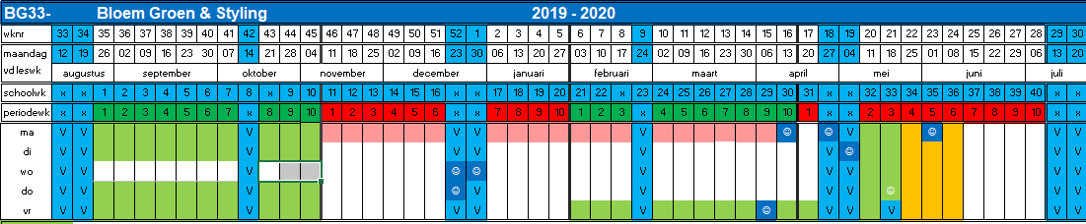

Periode 1:
BPV dag(en) weergegeven in groen
Aantal BPV uren: 320 = 40 dagen
Periode 2:
BPV dag(en) weergegeven in groen
Aantal BPV uren: 144 = 18 dagen

